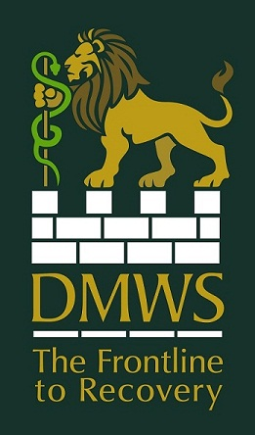

Application for Employment
Please complete in your own handwriting or electronically

EMPLOYMENT IS SUBJECT TO SECURITY VETTING, CRB CLEARANCE, RECEIPT OF SUITABLE REFERENCES AND THE PASSING THE ORGANISATION’S MEDICAL EXAMINATION. THE SUCCESSFUL APPLICANT WILL BE REQUIRED TO COMPLETE A HEALTH DECLARATION AND RETURN IT DIRECTLY TO DMWS’ OCCUPATIONAL HEALTH ADVISOR.

For the position of:

TITLE: FORENAME: SURNAME:

HOME ADDRESS:  Postcode:  Telephone:  Mobile:  Email: | WORK ADDRESS (if applicable):  Postcode:  Telephone:  Can you be contacted at work: YES:  NO:
NATIONALITY:

ARE YOU LEGALLY ENTITLED TO WORK IN THE UK: YES: NO:

CURRENT DRIVING LICENCE STATUS(essential requirement):

FULL LICENCE: YES: NO:

PROVISIONAL: YES: NO: Anticipated date of test:___________________

Please give details of any driving offences currently under endorsement:

How did you hear about this vacancy?

Have you made any previous applications to DMWS? YES: No:

If YES, please give details:

SECONDARY EDUCATION

School | Dates | Qualifications Gained | Result/Grade

FURTHER EDUCATION

College/University | Dates | Qualifications Gained | Result/Grade

HEALTH / SOCIAL / WELFARE QUALIFICATION:

College/University | Dates | Qualifications Gained | Result/Grade

OTHER SKILLS (Accounts / Apprenticeships / Professional Membership, etc).

IT SKILLS/QUALIFICATIONS (ECDL and software packages used)

LANGUAGES (Specify standard, spoken and written)

EMPLOYMENT HISTORY- Continue on a separate sheet of paper as necessary. Begin with present/last job and include any service in H.M. Forces.
Dates | Employer | Type of Business | Position Held | Responsibilities | Reason for leaving

Date available to work, or notice required:

Salary in present/last position:

OTHER INTERESTS AND ACTIVITIES Please give details of your main interests and the depth to which these are pursued.

Statement on how you meet the specific requirements set out in the personal specification of the job description.
REFEREES: Please name two professional referees. One should be from your present/last employer/school or college. Employment is subject to satisfactory references, but these will not be taken up without prior consent.

Name: Name:
Address: Address:

Telephone: Telephone:
Position: Position:
Length of association: Length of association:
I CONFIRM THAT ALL THE ABOVE INFORMATION IS CORRECT

Signed:________________________________ Date:_________________

Please return to:
Director Corporate Services (DCS) at recruitment@dmws.org.uk
or by mail to:
The Old Stables Redenham Park Redenham Nr Andover SP11 9AQ
T: 01264 774000 / F: 01264 773677

St John and Red Cross Defence Medical Welfare Service. Registered in England & Wales as a Company Limited by Guarantee
Company Registration no. 4185635,Registered Office and Head Quarters, The Old Stables, Redenham Park, Redenham, Nr Andover, SP11 9AQ
Telephone 01264 774000 Fax 01264 773677 Email: admin@dmws.org.uk Website: www.dmws.org.ukRegistered Charity No. 1087210

