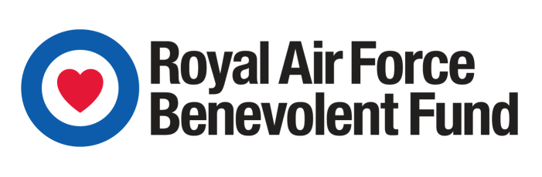

JOB PROFILE: COMMUNITY ENGAGEMENT WORKER
Role: | Community Engagement Worker | Date profile last reviewed: |  | DECEMBER 2021
Name: |  | Reports to: |  | COMMUNITY ENGAGEMENT MANAGER
MAIN SUMMARY OF ROLE:

This role has three key aims:
1. To support the Fund’s work on social isolation by engaging beneficiaries in socially enriching activities to reduce their isolation which in turn should, over time, reduce their feelings of loneliness.
2. To act as the ‘local welfare representative’ and promote the RAF Benevolent Fund.
3. To support the Fund’s caseworking function when required by assessing the welfare needs of members of the RAF Family, completing applications, providing recommendations for support to Welfare Executives, supporting access to statutory welfare support and support from other appropriate charities.
KEY ACCOUNTABILITIES/RESPONSIBILITIES:
- Hold a caseload of social isolated beneficiaries. Undertake assessments of beneficiary situations and barriers to engagement in socially enriching activities. To do so both remotely (over the telephone and online) and when required in person through home visits across your area of responsibility. This could involve significant amounts of travel to reach appointments.
- Develop action plans with each beneficiary entering the Community Engagement service. Plans should identify appropriate opportunities from within both the RAF Benevolent Fund but also the wider county to connect the beneficiary into at least one on-going socially enriching activity (e.g. Befriending, TFG, local veterans group); identify barriers to accessing that socially enriching activity and propose solutions to overcoming those barriers. This could on occasion involve accompanying a beneficiary to a social activity. Maintain the action plan as a means of keeping a clear exit strategy from the CEW intervention.
- Undertake casework to access financial assistance in support of executing individual beneficiary action plans. Coordinate support with the Fund’s professional advocacy service when appropriate in support of executing individual beneficiary action plans.
- Develop and maintain a thorough and detailed understanding of Fund support services and support services provided by other military charities and national veterans welfare services. Identify additional welfare needs of CEW beneficiaries and use this knowledge to refer them to an appropriate part of the Fund or external agency who can meet that need.
- Answer questions from key stakeholders and members of the RAF Family regarding available welfare support; sharing referrals for general welfare support with the Welfare Navigator team and when appropriate, liaise between stakeholders and head office to troubleshoot any ongoing issues in the delivery of welfare support.
- Promote the range of welfare support available from the RAF Benevolent Fund to key stakeholders in your county. Encourage stakeholders to identify member of the RAF Family amongst their service users and to signpost those individuals to the Fund. Focus on promoting the CEW role and encourage stakeholders to identify and refer socially isolated members of the RAF Family.
- Support the creation, development and delivery of activities aimed at reducing social isolation.
- Maintain up to date, concise and confidential, electronic beneficiary case notes, including case action plan notes, on CARE and CMS2 database systems.
- Ensure that you engage with the Area Director to ensure that your roles are complementary.

COMPETENCIES REQUIRED FOR THE ROLE
Essential |  |  | Desirable
- Working with people  - Relating and networking  - Deciding and initiating action  - Delivering results and meeting customer expectations  - Analysing  - Persuading and influencing |  |  | - Coping with pressures and setbacks  - Writing and reporting  - Planning and organising  - Following instructions and procedures  - Learning and researching  - Presenting and communicating information
QUALIFICATION(S), KNOWLEDGE, SKILLS AND EXPERIENCE REQUIRED FOR THE ROLE
Academic or Professional Qualifications (or equivalent):
Essential |  |  | Desirable
- A good level of general education – minimum of three A-Levels or equivalent, or life skills equivalent to this. |  |  | - Evidence of Continuing Professional  Development (CPD)
Knowledge/ Experience:
Essential |  |  | Desirable
- Experience of working with members of the  - public, organisations, community groups and health & social care professionals.  - Experience of supporting people to address their welfare needs using assessment and case management.  - Experience of working with older and/or vulnerable people.  - Knowledge of social and community services, including veteran’s services across the county.  - Experience of gathering information and presenting to groups of people. |  |  | - Experience and understanding of what it means to take a person-centred approach.  - Experience of delivering welfare services within a charitable organisation or the RAF.  - Knowledge of the public/social policy agenda around tackling social isolation and loneliness.  - Knowledge of the veteran’s welfare charity sector.  - Demonstrable knowledge of social and welfare issues affecting the ex-Service community.
Skills/Abilities:
Essential |  |  | Desirable
- People management and leadership skills
- Ability to positively influence at all levels
- Strong communication skills
- Creates personal credibility
Other Requirements:
- Full clean driving licence required
- Willingness to work flexible hours, outside of traditional office hours.

Signature

I confirm this job profile has been drawn up with my full involvement and accurately reflects the responsibilities of the role.

Postholder's Signature: NAME:

Line Manager's Signature: NAME:

Date:

